Contact: William Flowers
Owner, D.C. Cyclones
infodccyclones@gmail.com
(773) 919-2926
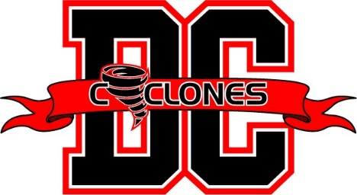
DC Cyclones
Women’s Pro Basketball Team
WASHINGTON, Md. July 31 - We’re back - packing more power, more talent, and more excitement than ever!
We’re the D.C. Cyclones, a founding member of the Women’s American Basketball Association (WABA), which is entering its second season, ready to build on the success and the popularity of its first.
The WABA is the sister league of the men’s ABA, which started in the mid-1960s and had such legendary stars as Julius Irving and Connie Hawkins. We and the rest of the WABA are now creating our own legacy with our own young stars.
We welcome back a number of our players, including Ashley Davis, Nickia Gibbs and Keyanna Tate. They will be joined by key rookies, including two from the D.C. area - Myla Somerville who was a standout at the University of the District of Columbia and Kyah Proctor, who scored more than 1,000 points in her career at Bowie State.
We play all our home games at the Boys and Girls Club of Greater Washington, 1901 Mississippi Ave. SE, Washington, D.C.
Our first game is set for Aug. 11th at 4 p.m. against Steel City, followed by:
• Aug. 12, 1 p.m. vs. Cleveland Blaze
• Aug. 18, 4 p.m. vs. MD Jewel
• Sept. 15, 4 p.m. vs. Jersey Expressions
Admission: $5.
Our new coach is Ryan Exum, who won championships at Hostos Community College in Bronx, N.Y., will be facilitating the charge for the championship.
D.C. Cyclones Owner William Flowers said, “We provide fast-paced, high-spirited, family entertainment that will have you standing, cheering for more.”
In addition to being a WABA pioneer, Flowers is a leadership consultant, certified performance enhancement specialist and basketball coach. He has also partnered with local women- and minority-owned businesses to promote small enterprise in the D.C. area.
“Our players want to move up,” Flowers said. “They are showcasing their skills to agents who represent players in the Women’s National Basketball Association as well as in pro leagues overseas. My goal is to help these women reach the pinnacle of their basketball careers, and then, after basketball, help them succeed in business.” We provide our players’ new opportunities, and our fans a dynamic team to cheer,” Flowers said.

